Workflow: Creating a Review Session in Advarra Electronic Regulatory System (eReg)
Purpose:
To guide study teams through the process of creating Review Sessions in Advarra eReg.

Overview:
Review Sessions facilitate the sharing of regulatory documents for monitoring visits, audits, or other types of reviews.
- Reviewers with access to your eReg can review documents directly from the Review Session.
- Reviewers without access to your eReg can review documents that you download from the Review Session and share in a ZIP file via a secure method.

Before Starting:
- Complete eReg training to gain login access to eReg.
- Verify the study protocol is created and active in eReg.
- Verify you are listed as study staff on the protocol in eReg.
- Verify your role is <<insert role>>.
- If the Reviewer will access eReg directly, verify the Reviewer completed eReg training and obtained an eReg login.

Login and Access
- Go to: Login | Advarra
- Login using your credentials.
- If you need access to eReg complete a request form.

Tips for Success
- Use consistent naming conventions for Review Sessions (e.g., Monitoring Visit - May 2025 or MON-01, MON-02).
- Configure a Review Session in advance of the scheduled review date.
- Access a Review Session to double-check that the Reviewer can view the documents.
- Notify the Reviewer when a Review Session is ready.
- If the download feature is used, then share the documents in a ZIP file via a secure method.
- For more information on review sessions login to eReg and visit the Learning Portal.

Review Session: Step-by-Step Instructions and Screenshots Are Listed Below
Steps | Screenshots
In the Menu, select Review Sessions | Navigate to the Review Session  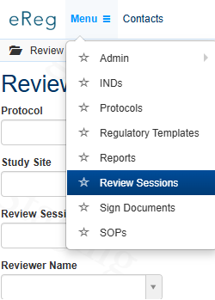
On the right, select  + New Review Session | 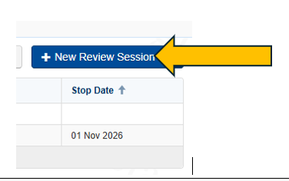  New Review Session
Name: Assign a name (e.g., MON-01 Monitoring Visit - April 2025).  Protocol:  Dropdown menu: assign protocol.  Review Session Type: Dropdown menu: Sponsor Monitoring, FDA Audit, and Internal Audit.  Reviewers: Search by typing name(s), more than one name can be added.  Start Dates: Enter start date.  End Dates: Optional, enter stop date. | Complete the *required fields listed below:  Create Review Session  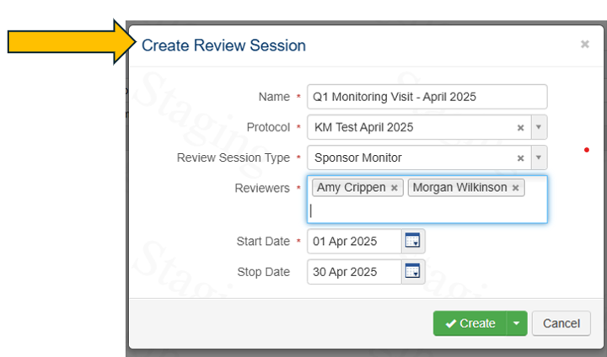
On the right, select Choose Sections. From the selections pop-up, click applicable checkboxes for the Review Session.  On the right, select Choose Requirements. From the requirements pop-up, click applicable checkboxes for the Review Session  Confirm the Review Session Configuration and Click Save. | 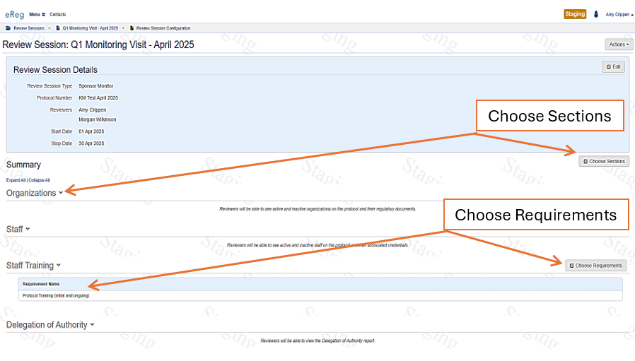  Review Session Configuration  Click the applicable checkboxes on the pop-ups for Section and Requirements, then save.
  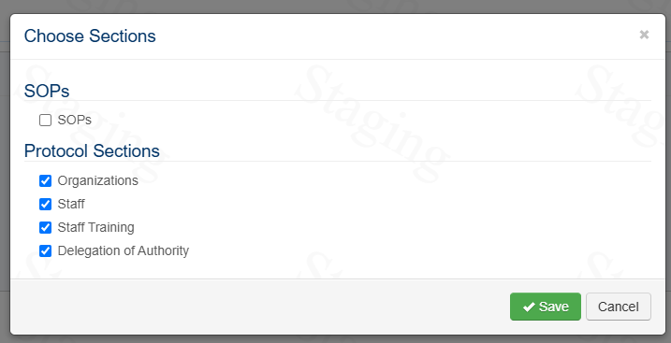 | 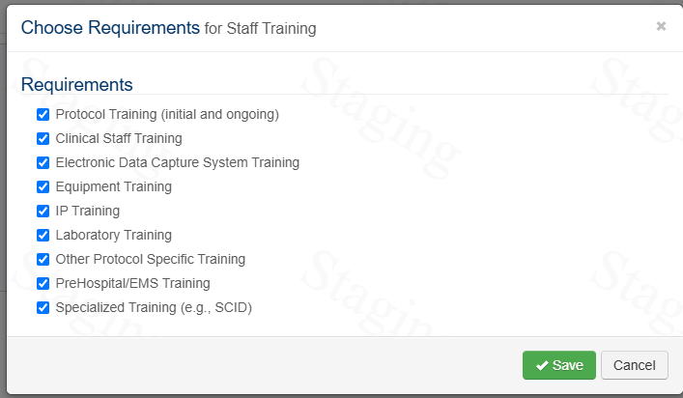
In the Menu, select Review Sessions  Search for a Review Session by protocol, study site, review session type, and/or reviewer name.  Another option is to use the Search field to search for a Review Session by name. | Searching for Saved Review Sessions
  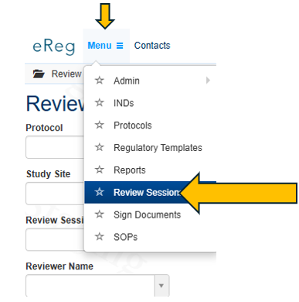 | 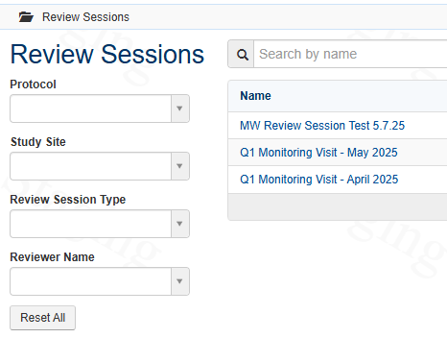
Search for your Review Session (see above).  On the right, select Actions and then select Configure Review Session. | Repeat the steps in Review Session Configuration to make edits.  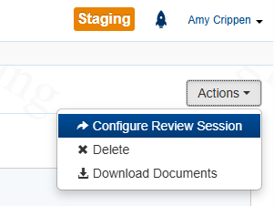  Editing Review Session
If the Reviewer does NOT have eReg access: Confirm all the Sections and Requirements are ready to be reviewed and then follow the steps below to download documents.
Downloading Documents for Monitors Without eReg Access

Search for your Review Session (see above).  On the right, select Actions and then select Download Documents.  Select the Section Names for export by using the checkboxes.  On the lower right corner select Download Documents. | 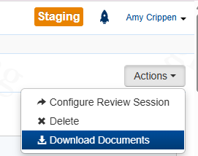  - The pop-up (image below) to confirm which Sections have been selected by checking the boxes for the Download.  - Click “Download Documents”  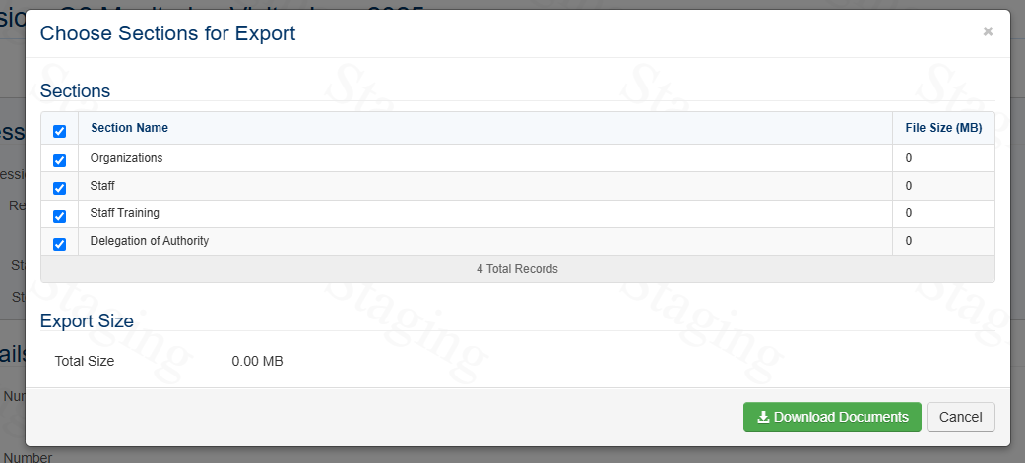
A Queued Tasks pop-up will appear. On the lower right corner select View Output.  Documents will be downloaded to a ZIP file (may take time depending on file size). Share the ZIP file via a secure method. | 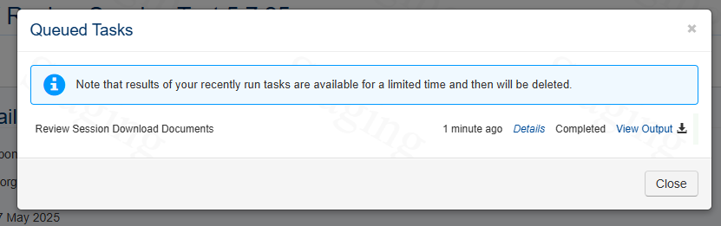

Accessing the Learning Portal
On the left, click on your name then select  Learning Portal | More information is available on the eReg Learning Portal by searching for Review Sessions. You must be logged in to access the portal.  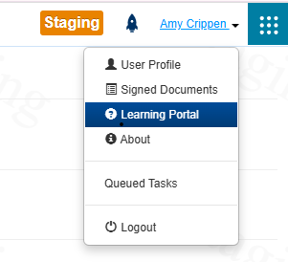
On the left search the Table of Contents by typing review sessions or by scrolling through the Table of Contents. | 